

**St. Joseph’s N.S. Bree/**

**SN Seosamh Naofa, Brí**

**2020/2021**

***Information Booklet for Parents of Junior Infants***

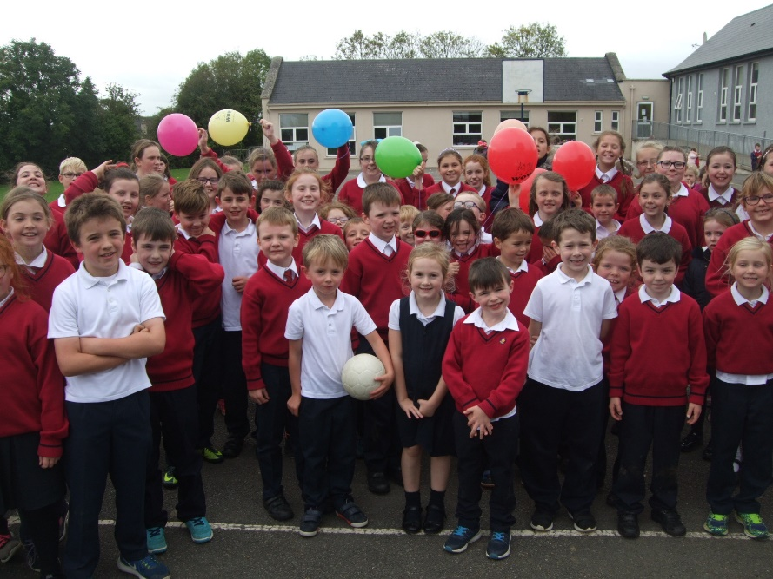

**St. Joseph’s N.S. Bree**



**Principal:** Mr. Mark Kelly  **Chairperson:** Fr. Michael Byrne

**Deputy Principal:** Mrs. Anne O’Dowd

Dear Parents,

Welcome to St. Joseph’s NS, Bree!

We hope that you and your child will spend eight very happy and fulfilling years with us. Our school aims to foster the physical, social, academic and spiritual development of the children. We cherish the self-esteem and individuality of each child, emphasising their many and varying gifts.

This booklet is divided into two parts. The first part aims to give you some hints and tips on how to ensure that your child gets the best possible start in primary school. The second part contains school information that you may find useful.

If we can help you with any other queries or questions, please don’t hesitate to contact us at the school.

Mark Kelly, Principal.



**Part One**

|  |
| --- |
| Introduction |

Starting school will be the first big change in the life of your child. Up to this your child has felt safe and secure with you in the home and family but now your child is facing the wider world of classroom and school. This may seem a big step for someone so small but most children manage it without any great fuss and take to it like ducks to water.

However it is also a time when parents and teachers should take special care to ensure that the transition from home to school is as smooth as possible. If the child’s first experience of school is one of happy involvement, a very good foundation will have been laid for fruitful school years ahead.

|  |
| --- |
| Getting Ready For Learning |

Our first year in school is mainly about settling in, relating to others, making friends, feeling happy and gradually getting used to the routine of the school.

On the learning side the emphasis is on getting children ready for learning by:

* Developing their oral language and expression
* Sharpening their senses, especially seeing, hearing and touching.
* Developing physical co-ordination especially of hand and fingers.
* Extending their concentration span and getting them to listen attentively.
* Learning through play- the most enjoyable way.
* Co-operating with the teacher and the other children.
* Performing tasks by themselves.
* Working with others and sharing with them.

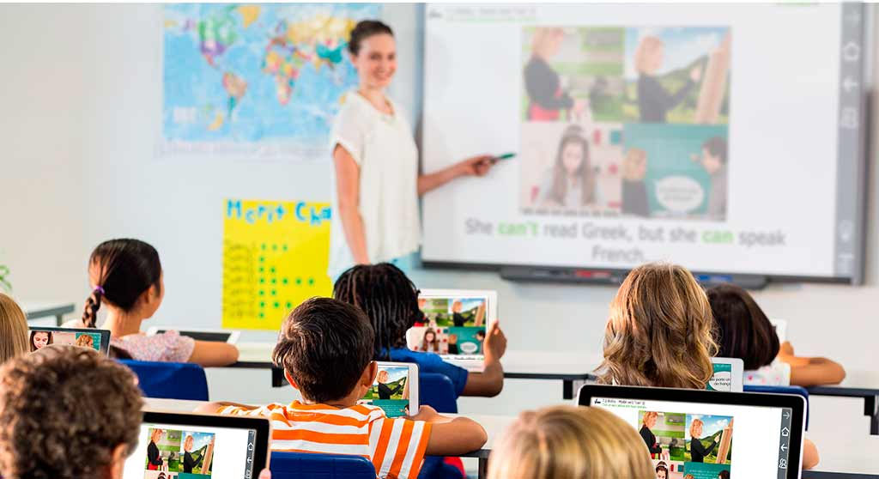

|  |
| --- |
| Before Your Child Starts |

You should ensure that your child is as independent as possible- physically, emotionally and socially. If your child can look after himself/herself in these areas he/she will feel secure and confident and settle in readily.

It would help greatly if your child is able to:

* Open and close his/her school bag and lunchbox.
* Button and unbutton his/her coat and hang it up.
* Use the toilet without help and manage buttons, zips.
* Flush the toilet and wash his/her hands, without having to be told.
* Use his/her hankie when necessary.
* Share toys and playthings with others and “take turns”.
* Tidy up and put away his/her playthings.
* Remain contentedly for a few hours in the home of a relation, friend or neighbour.

If children had this experience, then separation from their parents when they start school will not cause them any great anxiety.

**Please check your child’s schoolbag each night. There may be a note. Children often forget messages or relay them incorrectly.**

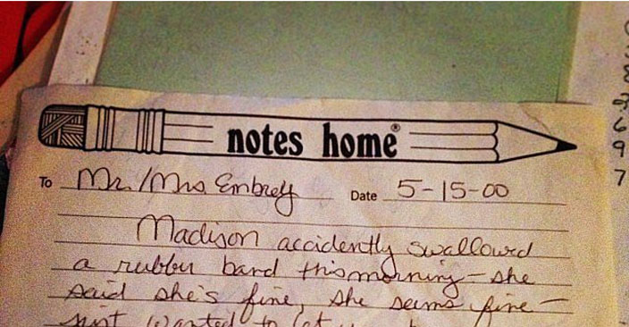

|  |
| --- |
| Preparing For The ‘Big Day’ |

Tell your child about school beforehand, casually, and talk about it as a happy place where there will be a big welcome for him/her and he/she will meet new friends.

Don’t use school or the teacher as a threat. “If you behave like that for teacher she’ll murder you”, though said light-heartedly, can make some children very apprehensive.

Your child’s books will be collected up the first day of school and the teacher will hold onto them until such time as they are needed. Please have your child warned of this fact; in case he/she thinks they will never see the books again! Often children only feel important when they have something in their schoolbag, so perhaps you could buy a copy or colouring book for your child, which they can use at home.

The development of an appreciation of sounds is an important pre-reading skill. An important way to practice the sounds of letters is through nursery rhymes. We would ask you to practice the following rhymes at home:

* Hey Diddle Diddle
* Humpty Dumpty
* I’m A Little Teapot
* Jack And Jill
* Baa, Baa, Black Sheep
* Hickory Dickory Dock
* Incy Wincy Spider
* Mary Had A Little Lamb

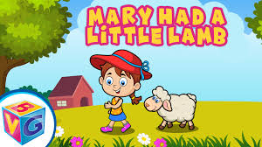

|  |
| --- |
| The Big Day |

When you arrive at the classroom, be as casual as you can. Your child will meet the teacher and the other children and can sit with a friend.

Hopefully your child will be absorbed in his/her new surroundings. So having assured him/her you will be back to collect him, wish him goodbye and make your getaway without delay.

|  |
| --- |
| The Upset Child |

In spite of the best efforts of both teacher and parent a small number of children will still become upset. If your child happens to be one of them don’t panic. Patience and perseverance can work wonders.

* **Trust the teacher.** She/he is experienced and resourceful and is used to coping with all kinds of starting - off problems.
* **Try not to show any outward signs of your own distress.** Sometimes the parents are more upset than the child and are the main cause of anxiety.
* **Leave quickly.** When you have reassured your child, leave the school! The teacher can distract and humour your child more easily when you are not around.
* **You must be firm from the start.** Even if a child is upset you must insist that they stay for a short time - even ten minutes.

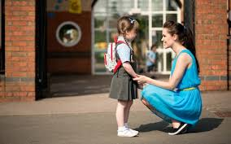

|  |
| --- |
| **Coming To School and Going Home** |

* School begins at 9.05 a.m. It is important that your child arrives at school on time. Early morning in class is activity time and is vital for social interaction. A child arriving late is often difficult to settle as all the other children are busy with their friends.
* Usually the drop-off and pick-up point will be the school yard (the basketball court section) located behind the main building. There will be an exception made for the Junior Infants for the first week or so, and they may be dropped off at the classroom door in the morning instead. We will aim to have all pupils lining up together in the yard as a class and entering school with their teacher after the first few weeks.
* Be sure to collect your child on time. School ends at 1.45 p.m. for infants and 2.45 p.m. for older children. Children can become very upset if they feel they have been forgotten. If you are running late please contact the school at 053 **9247725.**
* If at any time the collecting routine has to be changed please let us know and tell your child.
* Supervision is provided for ten minutes before and after the official school duration. **Children who arrive before 8.55 a.m. will not be supervised. Children must be collected by 2.55 p.m. at the latest.**

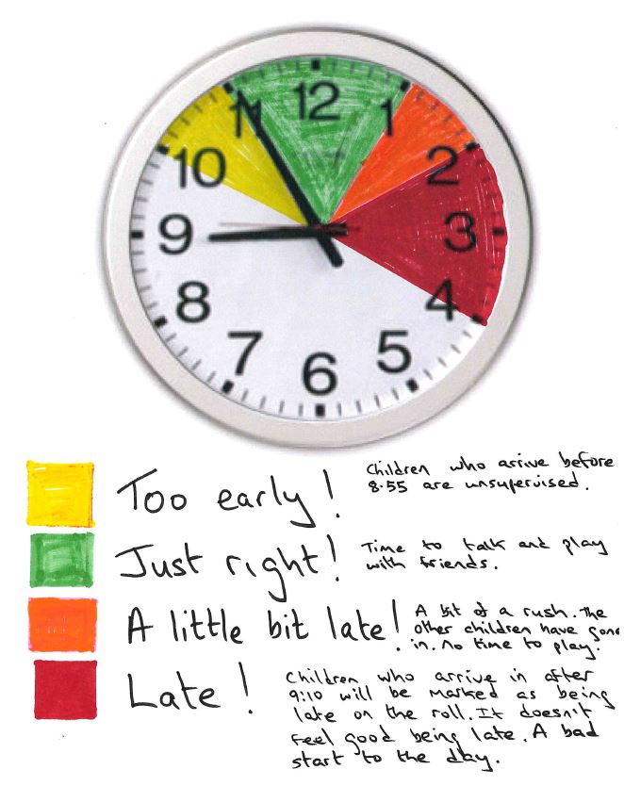

|  |
| --- |
| First Steps In Reading |

Ability to read is the foundation for all future progress in our school system. However learning to read is a gradual process and a lot of preparatory work must be done before a child is introduced to his first reader.

As well as building a strong oral language base children will experience a print-rich environment in the classroom, they will hear stories read to them and they will also be involved in reading “big books” with the teacher. Other activities include saying and chanting rhymes, playing games involving words that rhyme and breaking words into syllables. This helps the children to develop an awareness of the different sounds in words.

Great stress is also placed on developing the children’s ability to recognize the relationship between letters and sounds. These activities will lay the foundation for reading which will take place later sometime in Senior Infants.

We very deliberately do not rush or push children into reading. We get them ready for it over an extended period. Reading is something to be enjoyed. It should never be a chore for a small child.

**You can help:**

* Have attractive colourful books in the home.
* Read fairytales, jokes and storybooks to your child.
* You must convey that books need to be handled carefully and put away safely.
* Look at the pictures talk about what is happening
* Read nursery rhymes, they will be learnt off don’t force it.
* Sing the alphabet song with your child so that it becomes familiar.

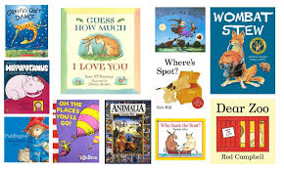

|  |
| --- |
| Understanding Maths |

Maths for small children has nothing to do with “sums” or figures or tables or adding or subtracting. These will come much later. Maths is really part of the language he uses in understanding and talking about certain things in his daily experience e.g.

Your child associates certain numbers with particular things- two hands, four wheels, five fingers, etc.

* Counting- one, two, etc.
* Colours - black, white, red, etc.
* Days of the week - associated with activities - P.E. Thursday, shopping Saturday, etc.
* Morning, afternoon, night
* Prepositions (telling position) and their opposites; over/under, before/after etc.
* Matching/Sorting – objects of the same size/colour etc.

Understanding of these concepts comes very quickly for some children. For others it takes a long time. Be patient. You cannot force maths understanding on a child.

**You can help:**

In the course of your ordinary daily routine in the home, in the shop, in the locality you should use suitable opportunities to casually introduce the maths vocabulary referred to above, e.g. how many knives and forks do we need? The glass is full/empty. We turn left at the traffic lights.

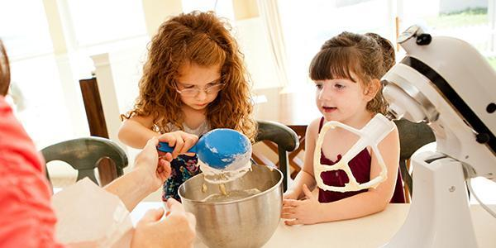

|  |
| --- |
| Getting Ready For Writing |

Making letters on paper is not easy for the small child. He must learn to hold the pencil properly and make regular shapes. His hand and finger muscles are only gradually developing at this stage.

**You can help:**

* Your child must develop the ability to get the hand and eye working together. This is very important. Get him/her manipulating toys like:

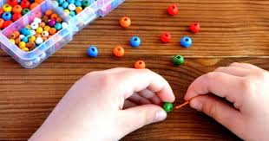

* Jigsaws, Lego, beads to thread etc
* Plasticine (Marla) to make his own shapes
* A colouring book and thick crayons
* Sheets of paper to cut up with a safe scissors
* When your child begins to use a pencil make sure that he/she holds it correctly and uses either his/her right hand or his left hand. Don’t discourage left-handedness. If that is your child’s definite natural inclination don’t discourage him.
* Your child may be making block letters at home even before he comes to school. This is fine. But when s/he makes lower case letters in school you should try to get him/her to practice his/her new system and discontinue the block letters.

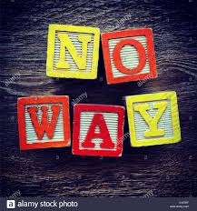

|  |
| --- |
| Learning the Letter Sounds |

In the infant classes the emphasis will be on the sound that the letters make at first, and then letter name. The teacher will be following the Jolly Phonics programme throughout the year, which they will continue through to second class.

The children will bring home a booklet of Jolly Phonics songs associated with the letter being covered in class.

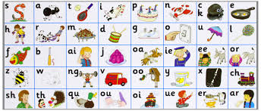

Other Areas of the Curriculum

The child in Junior Infants learns a lot through many other activities which do not need any elaboration here. The child’s general development is enhanced through art, PE, music, nature study and, of course, through religious education.

The children learn their prayers and bible stories gradually. Again, as in other areas we referred to already, the child will benefit from practising at home what he has learned in school. He/she can then make his own contribution to the usual family prayers.

If you do not want your child to participate in the religious programme, please make this known to the principal before the start of school in August/September. The school will make reasonable accommodations to ensure this.

Social skills are very important. We encourage good manners at all times, please/thank you, addressing teachers properly, being courteous to fellow students and teachers. It is important to ask your child whom she/he played with at school and to ensure he/she isn’t alone, and also to encourage mixing rather than being dependent on one friend only.

Rough behaviour is really discouraged in the playground.

**Conclusion**

This all sounds like a great deal of work, but it goes on in stages and is spread over a considerable period of time. Little and often is best. Your child may be tired after school but don’t worry. It is best to leave it than push too hard. There is no doubt that the extra effort on your part at this stage is well worth it.

**Part Two**

School Information

**Introduction**

St. Joseph’s NS/SN Seosamh Naofa is a twelve-teacher primary school situated in the parish of Ballyhogue. It operates under the patronage of the Catholic Bishop of Ferns. It is located near Enniscorthy.  
The present school was built in 1953, and had extensions added in recent years.   
The school has an enrolment of circa 225 children, with 8 mainstream classes and a staff of twelve teachers.   
St. Joseph’s N.S. aims to enable all pupils to realise their potential and to achieve satisfaction and success at their own level. It endeavours to create a happy, learning environment in which respect and a spirit of co-operation are promoted.

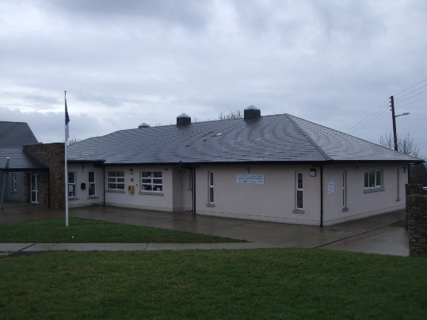

**National School Schedule for Catholic Schools**A Roman Catholic school aims at promoting the full and harmonious development of all aspects of the person of the pupil: intellectual, physical, cultural, moral and spiritual, including a living relationship with God and with other people. The school models and promotes a philosophy of life inspired by belief in God and in the life, death and resurrection of Jesus Christ. The Catholic school provides religious education for the pupils in accordance with the doctrines, practices and tradition of the Roman Catholic Church and promotes the formation of the pupils in the Catholic Faith.

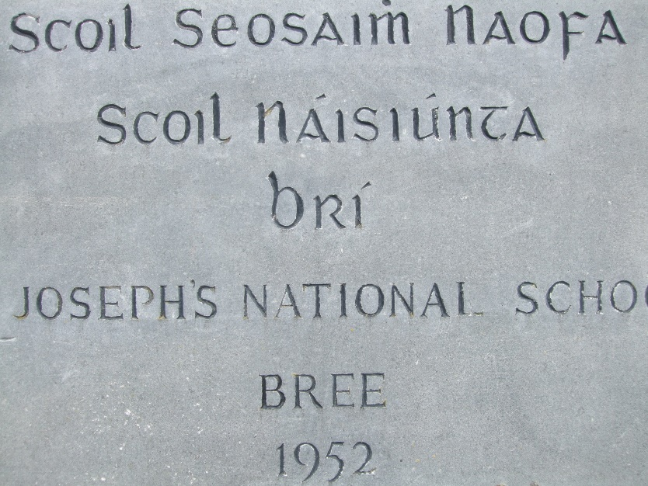

**Staff**

Principal: Mark Kelly   
Deputy Principal: Anne O’Dowd  
Management Team: Mark, Anne, Catherine Byrne and Larry Coffey.  
Teachers: Essie Morris, Marian Breen, Róisín Shannon, Caroline Miskella, Colm Moore, Aileen Laffan, Nora Wall and Aisling Carberry.  
Special Needs Assistants: Betty White, Aidriel Byrne and Lorna Hogan O’Gorman  
Secretary: Melissa Dawson  
Cleaner: Christine Redmond

Caretaker: Paddy Walsh

**Board of Management**  
The Board of Management consists of:

* Chairperson: Fr. Michael Byrne
* Principal and Secretary: Mark Kelly
* Patron’s Nominee: Clare Doyle
* Teachers' Nominee: Colm Moore
* Parents' Nominees: Alma Grannell and Mike Doyle
* Community Nominees: Betty Kelly and Sarah Ann Smith

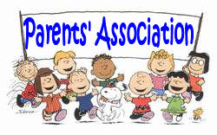

**Parents' Association**Chairperson:

Secretary: Jenny Sludds

Treasurer: Clodagh Martin

The Bree Parents' Association has been extremely helpful in helping the school in a variety of ways, ranging from fundraising, to feedback on school policies to preparing refreshments after school events. The Association has been a great asset to the school, and is much appreciated by the staff and Board of Management.  
  
Meetings are held on a regular basis. Parents are notified as to the time and date of meetings. The document "Supporting Each Other" is available on the school website. It is a very useful explanation of how schools and parents can work together in the education of a community's children.

**School Calendar**A copy of the school calendar is in this booklet. It is also available on the school website. A list of holidays is drawn up at the end of the school year, and the school year is now standardised by the Department of Education. We are allowed some flexibility with a small number of days. If there are any other unforeseen closures, curriculum days, or planning days, parents are notified as soon as possible.   
  
Families are asked to organise holidays around this calendar to avoid disruption to classes. Much of the revised curriculum now involves oral work, and this means children cannot be set work to take away with them: it must be done with the class teacher.

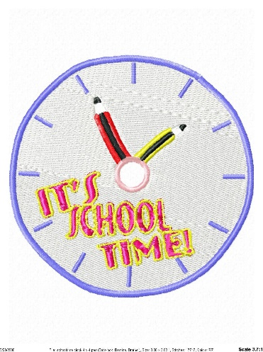

**School Times:**The official opening time is 9.05am. There will be no supervision before 8.55. The bell goes at 9.05am, and classes should line up in the basketball court. If it is wet, children will be brought in 8.55 and supervised by a member of staff. The school closes at 2.45pm. Please collect your child promptly.  
Children in junior and senior infants finish at 1.45pm and should be collected by a parent or guardian.   
  
Class times are as follows:  
9.05 am - Line up   
11.00am - 10 minute break.   
12.30pm - ½ hour lunch break.  
1.45pm - Infants’ Home time.  
2.45pm - Home time.

**Punctuality**   
All students should arrive at school in good time each morning and acquire a good habit of punctuality. Being late is a stressful experience for a child, and often affects their academic and social progress.

**Healthy Eating Policy**The school promotes healthy eating through its healthy eating policy. The children are encouraged to bring in only healthy lunches from Monday to Friday and are allowed to bring a small treat on Friday.

Also, due to serious nut allergies in the school, we ask parents not to give nuts, or foods containing nuts, to their children for lunch.



**Invitations/Cards**

It is school policy that invitations to birthday parties are not distributed in the school premises, out of consideration for non-receivers.

**Care of Hair**

Parents are asked to check their child’s hair regularly for outbreaks of head lice. If there is an outbreak of head lice in a class, parents of pupils in that class may be informed by note and asked to treat infestation.

**Head lice infection** is common in the community; the peak age for infection is 7-8 years. When two heads are touching for a minute or more, the lice climb rapidly through the hair from one head to another. They don’t jump, fly or swim and they aren't fussy about clean or dirty hair.

The infection can cause anxiety among parents, children and teachers. This sometimes leads to inappropriate actions for example, overuse of treatments or use of treatments which are not shown to be effective.

The above was taken from the HSE website.

**Phone Numbers**

Please ensure that the office has an up-to-date address, email address, eircode and phone number for parents/guardians/child minders. We regularly update parents of school events through our ‘text-a-parent’ service. We also need contact numbers in case of an emergency. We will then be able to contact you immediately if your child is sick.

**School Uniform**

**NB – To help with social distancing in September 2020, junior and senior infants will wear their tracksuits every day. The following applies to the older classes.**

The pupils of St. Joseph’s N.S. wear a school uniform, as decided upon by the parents. Children should bring in a note if they cannot wear the uniform on a particular day.

All pupils must wear the school uniform on Monday, Tues, Wed and school tracksuit on Thurs and Friday.

* Claret jumper
* Navy blue skirt/trousers
* Claret tie
* White shirt or white polo shirt underneath.
* Some pupils have navy blue shorts during hot weather.
* Tracksuit must be navy blue without any logo.

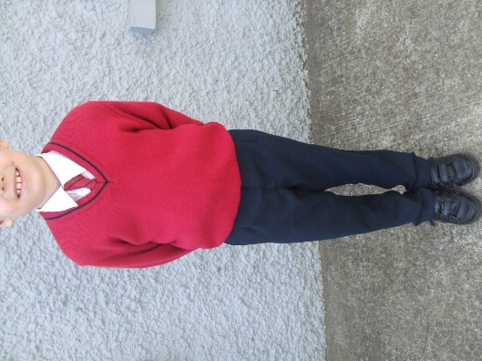 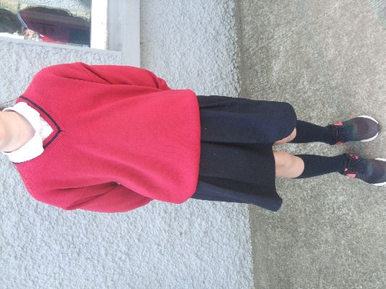 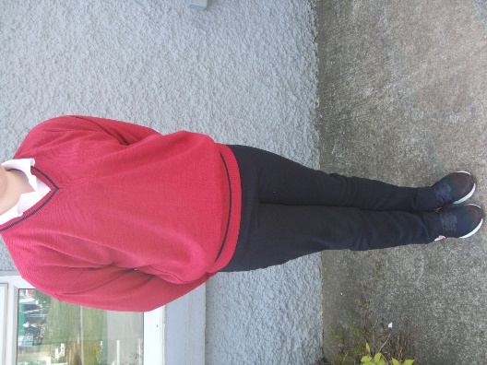

**Labels**

**Please label all items!** To avoid loss of personal property – jumpers, coats, tracksuit tops, lunch boxes, school bags etc. should be marked with names.

**School Fees**

Each year, parents pay for book rental, arts and crafts, and photocopying. The total is approximately €80.

**Books and Extra-Curricular Activities**Pupils will be given book lists at the end of the summer term. We are very conscious of the cost of schoolbooks and provide a rental scheme for most subject areas. Children are asked to buy their own workbooks for some subject areas.   
  
Children are encouraged to read extra books. Each classroom has its own library and extra library books are usually purchased annually with school funds.   
  
GAA coaching is provided after school with the help of parents and teachers. The school participates in the Rackard League, and has won a number of district and county titles recently. GAA and tag rugby coaching are also provided during school for the more senior classes.

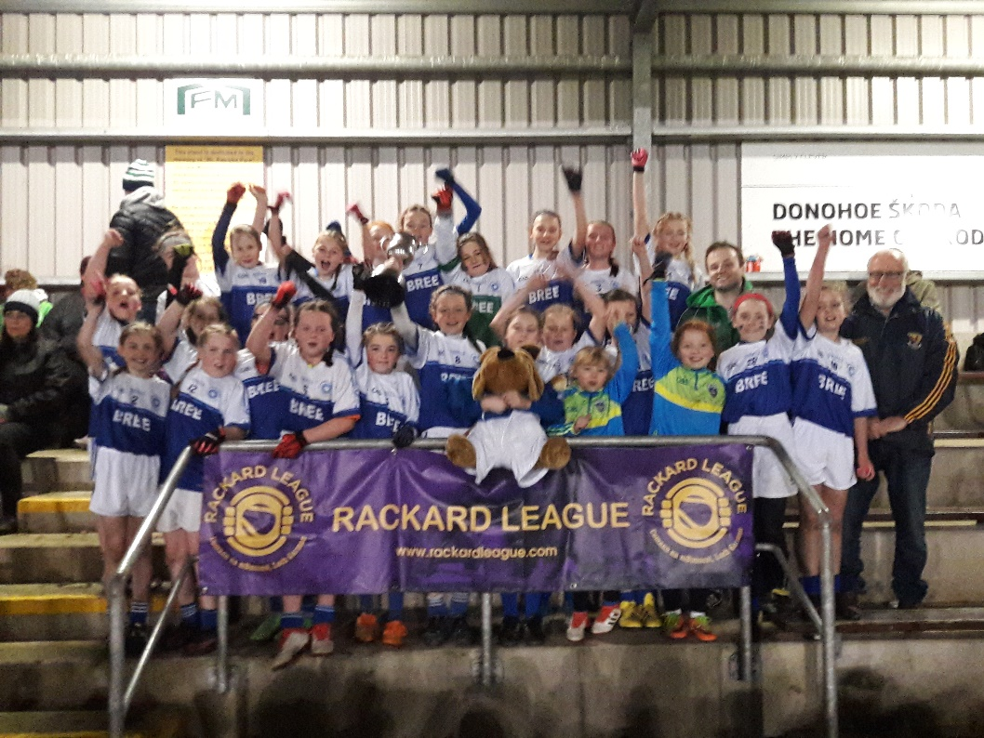

**Green Flag**The school must be kept tidy and free from litter, which is also part of the requirement to gain Green Flag status. Bins are provided in the classrooms and are emptied daily. Children are encouraged to keep the school litter free by taking any rubbish home and trying to not have too much packaging in lunch boxes.

**School Property**Pupils may not write on, deface or damage school property. Damage caused by them must be paid for. School equipment, books and property should be treated with due care.

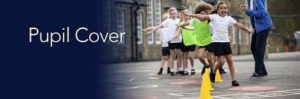

**Pupils’ Insurance**

Insurance for pupils in St. Joseph’s N.S. is available, and we recommend it especially for children involved in school sports. It costs €9 and gives the children **24 hour cover** for medical and dental expenses 24/7, 365 days a year. The cost of attending A&E can be €100 and this insurance has saved parents a lot of money.

**Appointments**

If a parent has an issue that needs clarification, he/she should, in the first instance, speak to the teacher. If you feel that it may take more than a minute, please make an appointment to meet before or after school.

If the issue needs further discussion, please make an appointment with the principal.



**Accidents**Accidents occur despite the excellent supervision provided in St. Joseph’s N.S. Minor accidents are treated at school on an *in loco parentis basis* – what a reasonable parent would do. In the event of a more serious accident or a child becoming very ill, every possible effort will be made to contact the pupil's parents or the persons delegated to take responsibility for that child.

**Child Protection**The Board of Management of St. Joseph’s N.S. has ratified its Child Safeguarding Statement. It has also adopted and will implement fully and without modification the Department’s Child Protection Procedures for Primary and Post Primary Schools 2017 as part of this overall Child Safeguarding Statement.

The Board nominates the Principal, Mark Kelly, as the designated liaison person (DLP) to act as a liaison with outside agencies such as health board and as a resource person to any staff having child protection concerns.  
Anne O’Dowd is the Deputy Designated Liaison Person (DDLP).

**Attendance**

Attendance at school is vital for a child’s educational progress. If a child is absent **for any reason**, for twenty days or more, the school must report the child to the National Educational Welfare Board (NEWB).

Please contact the school if your child is sick and send in a note when your child returns stating why they were absent (all absences without a note will be marked as unexplained).

**Further Information**

Lots of other useful information, including the school’s code of behavior, child safeguarding statement, anti-bullying and enrolment policies, can be found on the school website:

[www.breens.ie](http://www.breens.ie)

**Additional notes**

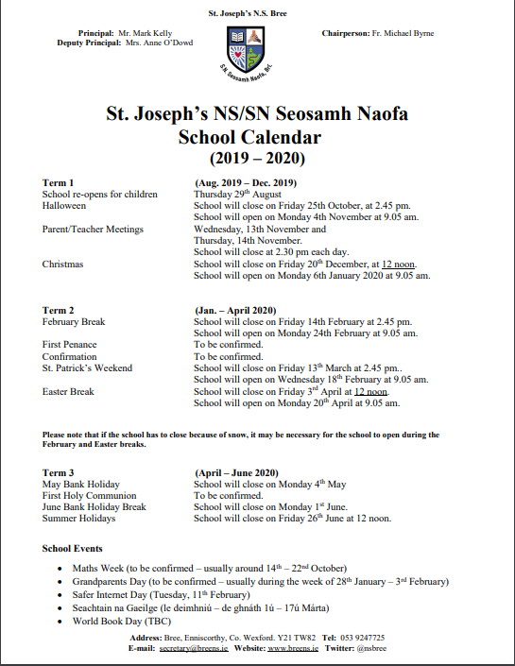

**NB – because of the uncertainty regarding school organisation for the school year 2020/21, a calendar for 20202/21 has not yet been finalized.**